College & University COVID-19 Updates

From COP | ICW | SBCTC
Each of these institutions has created a dedicated webpage for COVID-19 related updates. These links have the most up-to-date details about class and campus operations, housing, and other logistics.

- Bates Technical College
- Bellevue College
- Bellingham Technical College
- Big Bend Community College
- Cascadia College
- Central Washington University
- Centralia College
- Clark College
- Clover Park Technical College
- Columbia Basin College
- Eastern Washington University
- Edmonds College
- Everett Community College
- Gonzaga University
- Grays Harbor College
- Green River College
- Heritage University
- Highline College
- Lake Washington Institute of Technology
- Lower Columbia College
- North Seattle College
- Olympic College
- Pacific Lutheran University
- Peninsula College
- Pierce College
- Renton Technical College
- Seattle Central College
- Seattle Pacific University
- Seattle University
- Shoreline Community College
- Skagit Valley College
- South Puget Sound Community College
- South Seattle College
- Spokane Community College
- Spokane Falls Community College
- St. Martin's University
- Tacoma Community College
- The Evergreen State College
- University of Puget Sound
- University of Washington
- Walla Walla Community College
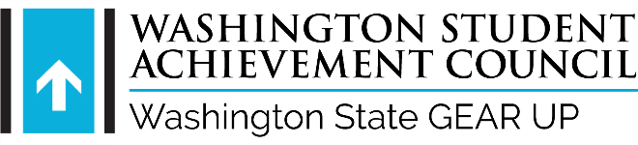
- Walla Walla University
- Washington State University
- Wenatchee Valley College
- Western Washington University
- Whatcom Community College
- Whitman College
- Whitworth University
- Yakima Valley College

